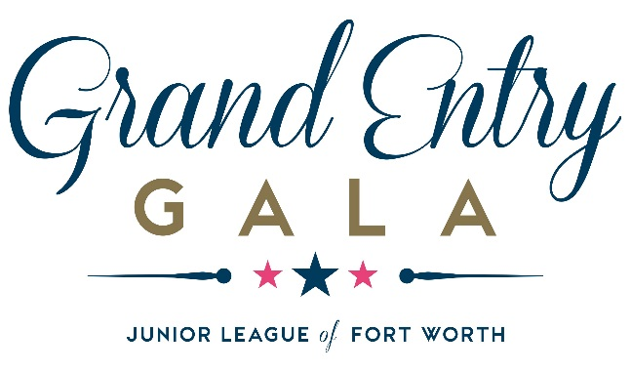

2017 Grand Entry Gala Sponsorship Form

Grand Champion Presenting Sponsor – $50,000 +
Specific recognition package details to be negotiated with the Junior League of Fort Worth, but will include:
- Title recognition in all Grand Entry Gala print materials including invitation
- Logo placement in the Fort Worth Stock Show & Rodeo Program
- Placement of company or foundation logo on the “Step and Repeat” signage
- VIP Table for 10 with Table Service
- 10 Tickets to Rodeo Art Reception
- Meet and Greet with Travis Tritt

Reserve Grand Champion Sponsor – $25,000
- Recognition in all Grand Entry Gala print materials including invitation
- Logo placement in the Fort Worth Stock Show & Rodeo Program
- Placement of company or foundation logo on the “Step and Repeat” signage
- VIP Table for 10 with Table Service
- 10 Tickets to Rodeo Art Reception
- Meet and Greet with Travis Tritt

Winner’s Circle Sponsor– $10,000
- Recognition in all Grand Entry Gala print materials including invitation
- Logo placement in the Fort Worth Stock Show & Rodeo Program
- Preferred Table for 10
- 10 Tickets to Rodeo Art Reception

Bronco Sponsor- $5,000
- Recognition in all Grand Entry Gala print materials including invitation
- Preferred Table for 10
- 10 Tickets to Rodeo Art Reception

Saddle Sponsor- $2,000
Limited Seating Available
- 4 Tickets to Rodeo Art Reception
- VIP Box Seating for 4 with Table Service
- Exclusive Commemorative Gift

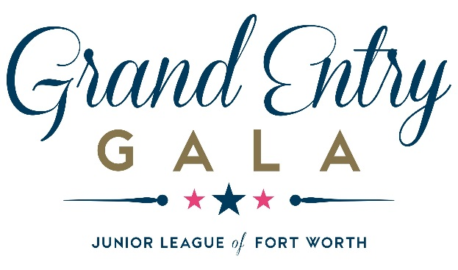

2017 Sponsorship Information

Contact Name/Organization:_____________________________________________________________________________________

Address: ____________________________________________________________________________________________________

City: _________________________________________________________ State: ______________ Zip Code: __________________

Day Time Phone: _____________________ Email Address: ___________________________________________________________

Sponsor Print Name: _______________________________________________________________
(As you would like it to appear in all print materials.)

Email address for communication/guest list confirmation: _____________________________________

Sponsorship Choice:_______________________________________________

Total Amount:_____________________________________________________

□ Enclosed is our check payable to the Junior League of Fort Worth
□ Secure online payment (grandentrygala.com)
□ Please charge our Credit Card □ Visa □ Mastercard □ Discover □ American Express

Credit Card #:________________________________ Expiration Date: _______ CVV Code:_________

Signature:____________________________________________

Thank you for your support! All proceeds benefit the Junior League of Fort Worth.
The Junior League is a 501(c)(3) tax-exempt organization. Please return payment and form to:
Grand Entry Gala
Junior League of Fort Worth
255 Bailey Avenue
Fort Worth, TX 76107
817.332.7500 phone
817.332.3902 fax
funddevelopment@juniorleaguefw.org

