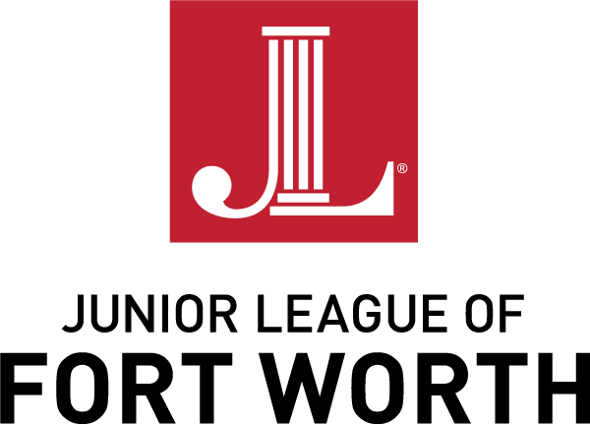

2019-2020 Partnership Applications & Opportunities

JLFW  Committee | Volunteers? | Funding? | Application Description
Projects | Y | Y | Deadline: Friday, May 31, 2019  Application includes request for funding and a volunteer component (can be related or unrelated to the funding request). Each JLFW volunteer to complete 50 hours. Available online for download; submitted via email and hard copy to JLFW office.  Contact: Amanda Baker, Project Research & Development Chair  jlfwprojects@gmail.com
Placements | Y | N | Deadline: Friday, May 31, 2019  Application is for volunteers only. Each JLFW volunteer to complete 50 hours of service in a particular program. Submissions received online.  Contacts: Mindy Hollan  & Aarti Puskoor, Placement Co-Chairs  jlfwplacement@gmail.com
Done-in-a-Day | Y | N | Deadline: At least 60 days prior to event  Online application is for short-­term volunteer requests only. Each JLFW volunteer to complete a 3-hour shift.  Contacts: Danielle Dollahite  & Elizabeth Knuckley, Done-in-a-Day Co-Chairs  jlfwdiad@gmail.com
Day of Giving | Y | N | Deadlines:  - Friday, September 27, 2019 – for FALL Day of Giving to be held on November 2, 2019  - Friday, February 21, 2020 – for SPRING Day of Giving to be held on April 4, 2020  Online application for community--wide day of volunteer service. To be completed by JLFW volunteers in 3–hour shifts.  Contacts: Kristina Robertson  & Rachel Phillips, Day of Giving Co-Chairs  dayofgivingjlfw@gmail.com  Con
Community  Opportunity  Fund Grants | N | Y | Deadline: Ongoing/rolling  - Emergency Fund Grants – Requests for critical or urgent need funds that typically do not exceed $2,500 per request  - Community Sponsorship Grants – Requests for event sponsorships not to exceed a JLFW annual total of $10,000  Contact: Brittyn Brender, Assistant Finance Vice President  cofjlfw@gmail.com

