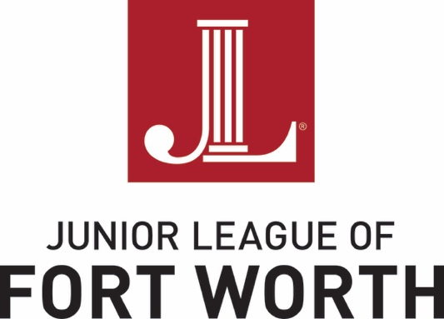

Using the Junior League of Fort Worth (JLFW)
Community Agency Portal on juniorleaguefw.org

Purpose
The Agency Portal will foster communication between JLFW and community organizations, as well as provide a centralized location for announcements, application submissions and ongoing outreach.

Key Steps
- Establish an account using this link: https://members.juniorleaguefw.org/?nd=agency_profile
This will prompt the creation of an organization’s username and password.
- Complete your profile with key agency information and points of contact.
- Distribute login info to the key points of contact within your organization that need to have access to the JLFW Community Agency Portal.
- Manage current and future applications (also available on the JLFW website)

Info to Know
- Each organization will have one username and password. The Agency username is for the organization and not for individuals using the system. Please share the log-in with all individuals within the organization who work with JLFW.
- All organizations will now have a homepage. On the homepage there are links to both update a profile or change the username and password.
- As your key points of contact change in the future, you can update the information on the Profile tab to ensure that the JLFW always has the most up to date contact information.
- The JLFW will post key resources for your reference on the Agency Resources tab of your home page.
- Every JLFW application is also available via the Community Agency homepage as well as the JLFW’s public website.
- Questions can be directed to Courtney Mooring, membership and Digital Cheetah administrator, at membership@juniorleaguefw.org.

