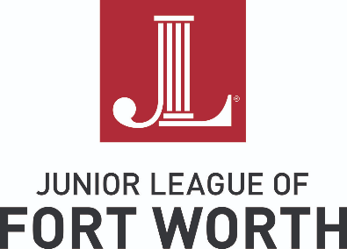
FOR IMEDIATE RELEASE  March 23, 2022 |  | Media Contact: Shay Johnson  Communications VP  Phone: 817-948-4864  Email:  communications.vp@juniorleaguefw.org

Junior League of Fort Worth announces Little Leaguers program
March 23, 2022 (Fort Worth, TX) -- The Junior League of Fort Worth (JLFW) has a new program that introduces children to volunteering and the League, called Little Leaguers. This program was developed by JLFW President Elizabeth Knuckley, and is open to all members and children of all ages. Member’s children, grandchildren, nieces, nephews and neighbors are all welcome to participate in the program.
The goal of Little Leaguers is to share the Junior League of Fort Worth’s commitment to voluntarism and community improvement. The program is also a way to improve children’s social skills, develop a sense of community, teach the power of gratitude and empathy and allows the member and child to bond while giving back to the community.
The Little Leaguers program is comprised of three components; donations, service and education. Donations are collected prior to the event, and during the event children are able to participate in volunteering as well as learn about the agency partner and their impact on the Fort Worth community.
In its inaugural year, Little Leaguers have already served The Welman Project, the JLFW Diaper Bank, the Ronald McDonald House, Meals on Wheels, ACH Child and Family Services, Community Storehouse, and Unbound. They have improved our community by donating almost 4,500 diapers, filling 100 reusable bags for new teachers, tying 30 fleece blankets, bringing toys and gifts for a “Christmas House” at Community Store house, and creating 40 bags for the women and children served at Unbound. JLFW’s Little Leaguers will continue to make an impact with these two events this spring: Trinity Park Trash Clean-up and a play at Casa Manana.
Agencies interested in partnering with the Little Leaguers are asked to contact the Junior League of Fort Worth.

About the Junior League of Fort Worth
The Junior League of Fort Worth, Texas, Inc. is an organization of women committed to promoting voluntarism, developing the potential of women, and improving communities through the effective action and leadership of trained volunteers. Its purpose is exclusively educational and charitable.
###

